# **CHAPTER 1**

# **INTRODUCTION**

## The Gas Leakage Detection System represents a pivotal advancement in safety technology, offering a sophisticated solution to mitigate the risks associated with gas leaks in various environments. Gas leaks, whether from natural gas pipelines, propane tanks, or industrial processes, present significant hazards including fire, explosion, and health risks due to exposure to toxic gases. To address these dangers, the Gas Leakage Detection System employs a network of interconnected sensors strategically placed to monitor gas levels continuously. These sensors are capable of detecting a wide range of gases, including liquefied petroleum gas (LPG), methane, propane, and carbon monoxide.

## At the heart of the system lies the ESP8266 microcontroller, a versatile and powerful platform that enables seamless integration of sensors and facilitates real-time data processing. By utilizing advanced sensor technology, the system can promptly detect even small traces of gas, ensuring early identification of potential leaks before they escalate into hazardous situations. The ESP8266 microcontroller serves as the central processing unit, collecting data from the sensors and analyzing it to determine the presence and concentration of gases in the environment.

## In the event of a gas leak, the Gas Leakage Detection System triggers immediate alerts to notify occupants and stakeholders. Audible alarms, such as buzzers or sirens, provide clear and unmistakable warnings. These alerts serve as crucial early warnings, allowing occupants to evacuate the premises swiftly and take appropriate safety measures to mitigate the risks posed by the gas leak.

## Moreover, the Gas Leakage Detection System can be enhanced with optional features such as IoT connectivity, enabling remote monitoring and control capabilities. Through IoT integration, users can access real-time data on gas levels and receive alerts on their smartphones or other connected devices, regardless of their location. This remote monitoring capability enhances situational awareness and enables proactive response measures, even when users are not physically present on-site. Additionally, the system automatically sends alerts to nearby fire stations, ensuring that emergency responders are notified promptly to take immediate action.

By combining these advanced features, the Gas Leakage Detection System not only empowers users with real-time insights but also facilitates a swift and coordinated response from emergency services. This comprehensive approach ensures that both occupants and first responders are well-informed, ultimately minimizing risks and enhancing safety during gas leak incidents. With such integrated capabilities, the system stands out as a vital tool in safeguarding lives and property from potential hazards.

## 

## 

Fig 1.1: Gas leakage

## **1.1: Problem Statement:**

Gas leakage poses a significant threat to both life and property in various settings, including residential, commercial, and industrial environments. The lack of real-time monitoring and early detection mechanisms increases the risk of accidents, fires, and health hazards associated with gas leaks. Traditional gas detection methods often rely on manual checks or standalone sensors, which may not provide timely alerts or comprehensive coverage. Therefore, there is a critical need for an advanced and interconnected gas leakage detection system that offers real-time monitoring, prompt alerts, and preventive measures to ensure safety.

The Gas Leakage Detection project aims to address these challenges by developing a comprehensive system that utilizes interconnected sensors to monitor gas levels in real-time. By leveraging advanced technologies such as IoT connectivity, the system provides continuous monitoring of gas levels across different locations, enabling early detection of leaks and timely interventions to prevent potential disasters. The integration of interconnected sensors ensures comprehensive coverage, allowing for the detection of various types of gases.

Key objectives of this project include the development of a network of gas sensors deployed strategically in areas prone to gas leaks, such as kitchens, boiler rooms, and industrial facilities. These sensors will continuously monitor gas levels and transmit data to a central control unit or cloud-based platform for real-time analysis. In case of abnormal gas levels or detected leaks, the system will trigger immediate alerts through visual indicators, alarms, and notifications to alert occupants and relevant authorities.

Furthermore, the Gas Leakage Detection system will support remote monitoring and control capabilities, allowing users to access real-time data and receive alerts on their smartphones or other devices. This enables timely response actions, such as shutting off gas supplies or activating ventilation systems, to mitigate the risk of accidents and minimize potential damages.

Overall, the Gas Leakage Detection project aims to enhance safety and mitigate the risks associated with gas leaks by providing a proactive and interconnected monitoring solution. By leveraging advanced sensors, IoT connectivity, and real-time alerts, the system empowers users to take preventive measures and ensure the safety of occupants and assets in various environments susceptible to gas leakage hazards.

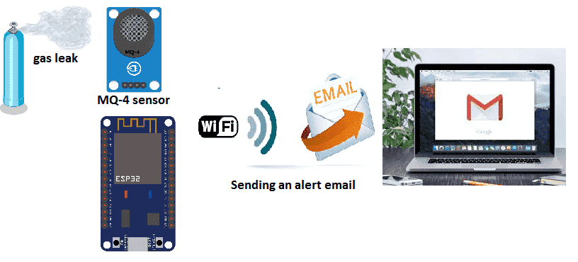

Fig 1.2: Technology behind gas leakage detection

## **1.2: Problem Scope**:

1. Lack of Real-time Gas Monitoring:

Challenges:

Manual Gas Monitoring: Traditional gas detection methods rely on manual checks or standalone sensors, which may not provide real-time monitoring capabilities.

Delayed Detection: Manual monitoring methods may result in delayed detection of gas leaks, increasing the risk of accidents and hazards.

Limited Coverage: Standalone sensors may offer limited coverage and fail to detect leaks in all areas susceptible to gas leakage.

Impact:

Safety Risks: Delayed detection of gas leaks poses serious safety risks to occupants and property, increasing the likelihood of accidents, fires, and health hazards.

Property Damage: Gas leaks detected late may result in significant property damage, including structural damage and loss of assets.

2. Lack of Comprehensive Gas Leak Detection:

Challenges:

Limited Sensor Coverage: Existing gas detection systems may lack comprehensive coverage, leaving certain areas vulnerable to undetected leaks.

Inadequate Sensor Sensitivity: Some gas sensors may have limited sensitivity, failing to detect low levels of gas leaks or certain types of gases.

Reliability Issues: Standalone sensors may be prone to reliability issues, such as false alarms or sensor malfunctions, leading to ineffective detection.

Impact:

Incomplete Detection: Inadequate sensor coverage and sensitivity may result in incomplete detection of gas leaks, leaving areas unprotected and increasing the risk of accidents.

False Alarms: Reliability issues with sensors may lead to false alarms, causing unnecessary disruptions and reducing confidence in the system's effectiveness.

3. Lack of Centralized Monitoring and Alert System:

Challenges:

Manual Notification Processes: In the absence of a centralized monitoring system, notifications of gas leaks may rely on manual processes, leading to delays in response.

Limited Alert Mechanisms: Traditional gas detection systems may lack comprehensive alert mechanisms, such as remote notifications or alarms, limiting the ability to respond promptly.

Difficulty in Coordination: Coordinating responses to gas leaks without centralized monitoring systems may be challenging, resulting in inefficient and delayed actions.

Impact:

Delayed Response: Manual notification processes and limited alert mechanisms may delay responses to gas leaks, exacerbating safety risks and increasing the severity of potential accidents.

Coordination Challenges: Without centralized monitoring and alert systems, coordinating responses to gas leaks becomes more difficult, leading to confusion and inefficiencies in emergency situations.

Conclusion:

The identified challenges underscore the critical need for an advanced gas leakage detection system that offers real-time monitoring, comprehensive coverage, and centralized alert mechanisms. By addressing these challenges and leveraging advanced technologies such as interconnected sensors, IoT connectivity, and centralized monitoring systems, the Gas Leakage Detection Project aims to enhance safety, mitigate risks, and ensure prompt responses to gas leaks, thereby safeguarding lives and property in various environments susceptible to gas leakage hazards.

## **1.3: Advantages:**

## Advantages of Gas Leakage Detection System:

## 1. Enhanced Safety and Risk Mitigation:

## - Early Detection: Gas leakage detection systems provide early detection of gas leaks, allowing prompt intervention and mitigation measures to prevent accidents or hazards.

## - Prevention of Health Risks: Timely detection of gas leaks helps prevent exposure to harmful gasses, reducing the risk of health complications or respiratory issues for occupants.

## - Property Protection: By detecting gas leaks early, the system helps protect property from potential damage or destruction caused by gas-related incidents such as fires or explosions.

## 2. Real-time Monitoring and Alerts:

## - Continuous Monitoring: Gas leakage detection systems continuously monitor gas levels in real-time, providing constant vigilance against potential leaks or abnormalities.

## - Instant Alerts: The system triggers instant alerts, notifications, or alarms upon detecting abnormal gas levels, enabling immediate response and intervention by building occupants or emergency personnel.

## - Remote Monitoring: Some systems offer remote monitoring capabilities, allowing users to monitor gas levels and receive alerts from anywhere via mobile applications or web interfaces, enhancing convenience and accessibility.

## 3. Prevention of Environmental Impact:

## - Environmental Protection: Gas leakage detection systems help prevent environmental pollution by minimizing the release of harmful gases into the atmosphere.

## - Compliance with Regulations: By ensuring compliance with environmental regulations and standards, the system helps organizations avoid fines, penalties, or legal liabilities associated with gas leaks and environmental violations.

## 4. Cost Savings and Efficiency:

## - Reduced Losses: Early detection and mitigation of gas leaks minimize potential losses associated with property damage, business interruptions, or insurance claims, resulting in cost savings for organizations.

## - Efficient Resource Allocation: By automating gas leak detection and response processes, the system optimizes resource allocation and reduces the need for manual monitoring, saving time and manpower.

## 5. Peace of Mind and Confidence:

## - Enhanced Security: Gas leakage detection systems provide occupants with peace of mind and confidence in their safety by offering continuous monitoring and proactive protection against gas-related hazards.

## - Trust and Reputation: Implementing robust gas leakage detection measures demonstrates a commitment to safety and responsible stewardship, enhancing trust and reputation among stakeholders, customers, and the public.

## 6. Integration and Compatibility:

## - Seamless Integration: Gas leakage detection systems can be seamlessly integrated with existing building management systems, security systems, or automation platforms, enhancing interoperability and functionality.

## - Compatibility with Sensors: The system supports various types of gas sensors and detectors, allowing flexibility in deployment and customization to suit specific needs and requirements.

## 7. Regulatory Compliance:

## - Compliance Assurance: Gas leakage detection systems help organizations comply with industry standards, regulations, and safety codes pertaining to gas handling, storage, and safety protocols.

## **In c**onclusion, the implementation of a gas leakage detection system offers numerous advantages, including enhanced safety, real-time monitoring, cost savings, environmental protection, and regulatory compliance. By investing in proactive gas detection solutions, organizations can safeguard lives, property, and the environment while fostering confidence, efficiency, and compliance in gas handling and safety practices.

## 

## **1.4 Proposed Solution:**

Proposed Solution for Gas Leakage Detection:

The proposed solution for gas leakage detection aims to enhance safety and efficiency by leveraging interconnected sensors and advanced technologies. Key components of the proposed solution include:

1. Gas Sensors:

- Enhanced Detection Capabilities: Utilizing high-quality gas sensors capable of detecting various types of gases, including methane, propane, and carbon monoxide, ensures comprehensive coverage and accurate detection of potential leaks.

- Sensitivity Adjustment: Gas sensors are equipped with sensitivity adjustment features to fine-tune detection thresholds according to specific gas concentration levels, minimizing false alarms and maximizing detection accuracy.

2. Interconnected Network:

- Real-time Monitoring: Interconnecting gas sensors into a network allows for real-time monitoring of gas levels across different areas or zones, enabling prompt detection and response to potential leaks.

- Data Sharing: The interconnected network facilitates seamless sharing of data between sensors, enabling centralized monitoring and analysis of gas levels, trends, and anomalies.

3. Alert System:

- Immediate Notifications: An alert system is integrated to provide immediate notifications in the event of gas detection, alerting designated personnel via visual, audible, or digital notifications to facilitate swift response and mitigation measures.

- Customizable Alerts: The alert system allows for customizable alert settings based on predefined thresholds, ensuring that appropriate actions are taken based on the severity of the gas leak.

4. Remote Monitoring and Control:

- Remote Access: The gas leakage detection system provides remote access capabilities, allowing authorized personnel to monitor gas levels, receive alerts, and take necessary actions from any location using a computer or mobile device.

- Control Features: Remote control features enable personnel to remotely activate or deactivate sensors, adjust settings, and initiate emergency shutdown procedures if required, enhancing operational flexibility and control.

5. Data Logging and Analysis:

- Data Logging: The system logs and stores gas level data over time, providing valuable insights into gas concentration trends, patterns, and historical data for analysis and reporting purposes.

- Data Analysis: Advanced analytics tools are employed to analyze gas level data, identify potential leak sources, and optimize preventive maintenance schedules to mitigate future risks effectively.

6. Integration with Building Management Systems (BMS):

- Seamless Integration: Integration with existing Building Management Systems (BMS) allows for seamless integration of gas leakage detection data with other building automation systems, such as HVAC and ventilation systems, to facilitate coordinated response actions in case of gas leaks.

- Cross-functional Coordination: The integration enables cross-functional coordination between gas detection systems and other building systems, enhancing overall safety and operational efficiency.

Conclusion:

The proposed gas leakage detection solution offers a comprehensive and proactive approach to enhance safety and efficiency in various environments. By leveraging interconnected sensors, real-time monitoring, remote access, and advanced analytics, the system provides timely detection, notification, and response to gas leaks, minimizing risks and ensuring a safer environment for occupants. Additionally, integration with existing building management systems enhances coordination and operational efficiency, making it a valuable investment for facilities seeking to prioritize safety and compliance with regulatory standards.

**1.5 Aim and Objectives**

**Aim:**

Aim of Gas Leakage Detection Project:

The aim of the Gas Leakage Detection project is to develop an advanced system that enhances safety, minimizes risks, and ensures prompt response to gas leaks in residential, commercial, and industrial settings. By integrating interconnected sensors, real-time monitoring capabilities, and automated alert mechanisms, this innovative system seeks to revolutionize traditional gas detection methods. The primary objectives include detecting gas leaks at an early stage to prevent accidents, minimizing health risks associated with gas exposure, and protecting property and the environment from potential damage. The system aims to provide continuous monitoring of gas levels, trigger instant alerts or alarms upon detection of abnormal gas levels, and enable remote monitoring and management for enhanced convenience and accessibility. Furthermore, the project focuses on optimizing resource allocation, reducing losses, and promoting environmental sustainability by minimizing gas emissions and pollution. Ultimately, the Gas Leakage Detection project aims to offer a reliable, efficient, and cost-effective solution that enhances safety, security, and confidence in gas handling practices across various sectors.

**Objectives:**

# 1. Early Detection and Prevention: Develop a system capable of detecting gas leaks at an early stage to prevent accidents, minimize health risks, and protect property and the environment from potential damage.

# 2. Real-time Monitoring and Alerting: Implement interconnected sensors and real-time monitoring capabilities to continuously monitor gas levels and trigger instant alerts or alarms upon detection of abnormal gas concentrations.

# 3. Remote Monitoring and Management: Enable remote monitoring and management of the gas detection system to provide administrators with convenient access to real-time data, allowing for prompt response and intervention from anywhere.

# 4. Enhanced Safety Measures: Integrate advanced security features to ensure the safety of personnel and property by restricting access to authorized individuals, preventing tampering, and maintaining the integrity of the gas detection system.

# 5. Compliance and Regulation Adherence: Ensure that the gas detection system complies with relevant safety regulations, standards, and industry best practices to uphold safety standards and legal requirements.

# 6. Optimization of Resource Allocation: Optimize resource allocation by reducing false alarms, minimizing emergency response times, and enhancing operational efficiency through automated monitoring and alerting mechanisms.

# 7. Environmental Sustainability: Promote environmental sustainability by minimizing gas emissions and pollution through efficient detection and mitigation of gas leaks, contributing to a cleaner and safer environment.

# 8. Scalability and Adaptability: Design the gas detection system with scalability and adaptability in mind to accommodate future expansion, technological advancements, and changing needs in residential, commercial, and industrial settings.

# 

# By achieving these objectives, the Gas Leakage Detection project aims to provide a reliable, efficient, and proactive solution for gas leak detection, ensuring safety, security, and peace of mind for users across various sectors.

# 

# 

# **CHAPTER 2**

# **Literature Survey**

# Literature Survey for Gas Leakage Detection Project:

# Gas leakage detection systems represent a critical component of safety measures in various settings, including residential, commercial, and industrial environments. The literature surrounding gas leakage detection highlights advancements in technology, methodologies, and applications aimed at enhancing safety, preventing accidents, and minimizing risks associated with gas leaks.

# Sensor Technology Advancements:

# Research in sensor technology has led to significant advancements in gas detection systems, with studies focusing on the development of highly sensitive and selective sensors capable of detecting various gases with high accuracy. Advances in sensor materials, fabrication techniques, and signal processing algorithms have contributed to the improvement of gas detection sensitivity, response time, and reliability.

# IoT and Connectivity Solutions:

# The integration of Internet of Things (IoT) technology in gas leakage detection systems has enabled remote monitoring, data analytics, and real-time alerts, enhancing the overall efficiency and effectiveness of gas detection systems. Studies explore the implementation of wireless sensor networks, cloud-based platforms, and mobile applications to facilitate seamless communication, data management, and decision-making processes.

# Artificial Intelligence and Machine Learning:

# The application of artificial intelligence (AI) and machine learning algorithms in gas leakage detection systems has shown promising results in predictive modeling, anomaly detection, and pattern recognition. Research in this area focuses on developing intelligent algorithms capable of analyzing complex data sets, identifying gas leakage patterns, and predicting potential hazards, thereby improving the proactive response to gas leakage events.

# Environmental Monitoring and Sustainability:

# Studies highlight the importance of environmental monitoring in gas leakage detection systems, emphasizing the need to consider factors such as temperature, humidity, and air quality in addition to gas concentrations. By integrating environmental sensors into gas detection systems, researchers aim to provide comprehensive monitoring solutions that not only detect gas leaks but also assess their potential impact on the surrounding environment and human health.

# Integration with Smart Home and Building Systems:

# The integration of gas leakage detection systems with smart home and building automation systems offers enhanced safety, convenience, and efficiency. Research in this area explores the interoperability of gas detection sensors with smart devices, home automation platforms, and building management systems to automate emergency response actions, trigger alarms, and notify occupants in case of gas leaks.

# Regulatory Compliance and Standards:

# The literature emphasizes the importance of compliance with regulatory standards and industry guidelines in the design, deployment, and operation of gas leakage detection systems. Studies discuss the relevance of standards such as UL 2034 (for residential gas detectors) and EN 50291 (for carbon monoxide detectors) in ensuring the reliability, accuracy, and safety of gas detection systems.

# Conclusion:

# The literature survey highlights the multidisciplinary nature of gas leakage detection research, encompassing advancements in sensor technology, IoT connectivity, artificial intelligence, environmental monitoring, and regulatory compliance. By leveraging these advancements, gas leakage detection systems aim to provide reliable, efficient, and proactive solutions for detecting, mitigating, and preventing gas leaks, ultimately enhancing safety and minimizing risks in various environments.

# 

# 

# 

# **CHAPTER 3**

# **Methodology**

In this phase, the electronic circuit design is centered around the **NodeMCU** as the primary control unit. The **MQ-135 sensor** is connected to detect harmful gases, and its data is processed by the NodeMCU. The system also integrates a **relay** to control external components, such as an **exit fan**, which is activated in the event of a gas leak to ventilate the area. A **buzzer** is added for audible alerts, while the **servo motor** is programmed to respond by potentially shutting off gas valves or triggering other mechanical safety measures.

**Software Development**

The Software Development phase involves writing code for the NodeMCU to handle continuous sensor readings from the MQ-135 sensor, which monitors gas levels. When gas concentrations exceed predefined safety thresholds, the system triggers several safety measures. The relay activates the exit fan to clear the air, while the buzzer sounds to alert nearby occupants. Additionally, the servo motor is controlled to perform mechanical actions, such as shutting off gas valves to prevent further leakage.

Beyond local actions, the system is equipped with IoT integration to enable remote monitoring and external notifications. The NodeMCU sends immediate alerts to the local fire station, ensuring that emergency responders are notified promptly to take swift action. Additionally, the system is connected to a custom MIT App Inventor-based app, which is designed to notify users in real time via their smartphones. The app provides critical information such as gas concentration levels and the system's response status, allowing users to monitor the situation remotely and take informed actions even when they are off-site. This comprehensive approach ensures both local and external safety responses are fully automated, keeping emergency services and users continuously informed.

NodeMCU

Buzzer

MQ-135 Gas sensor

Servo

Fan

Figure 3.1: Block Diagram gas leakage detection

## **3.1 NodeMCU (ESP8266 )**

The NodeMCU ESP8266 is a powerful and versatile platform designed for Internet of Things (IoT) development. It is a cost-effective Wi-Fi microchip known for its capability to enable wireless communication in IoT applications. NodeMCU, on the other hand, is an open-source firmware and development kit that simplifies the process of prototyping and programming the ESP8266, built-in Wi-Fi connectivity, the NodeMCU ESP8266 allows devices to connect to the internet wirelessly, making it suitable for a wide range of IoT projects. One notable feature is its support for the Lua scripting language, providing a high-level programming environment for developers. Additionally, it is compatible with the Arduino IDE, allowing those familiar with Arduino to use the NodeMCU platform. Equipped with General Purpose Input/Output (GPIO) pins, the ESP8266 facilitates interfacing with various electronic components, making it ideal for applications such as home automation and sensor networks. It has garnered significant community support, resulting in an extensive collection of libraries and documentation, making it a popular choice for rapid IoT prototyping and development.

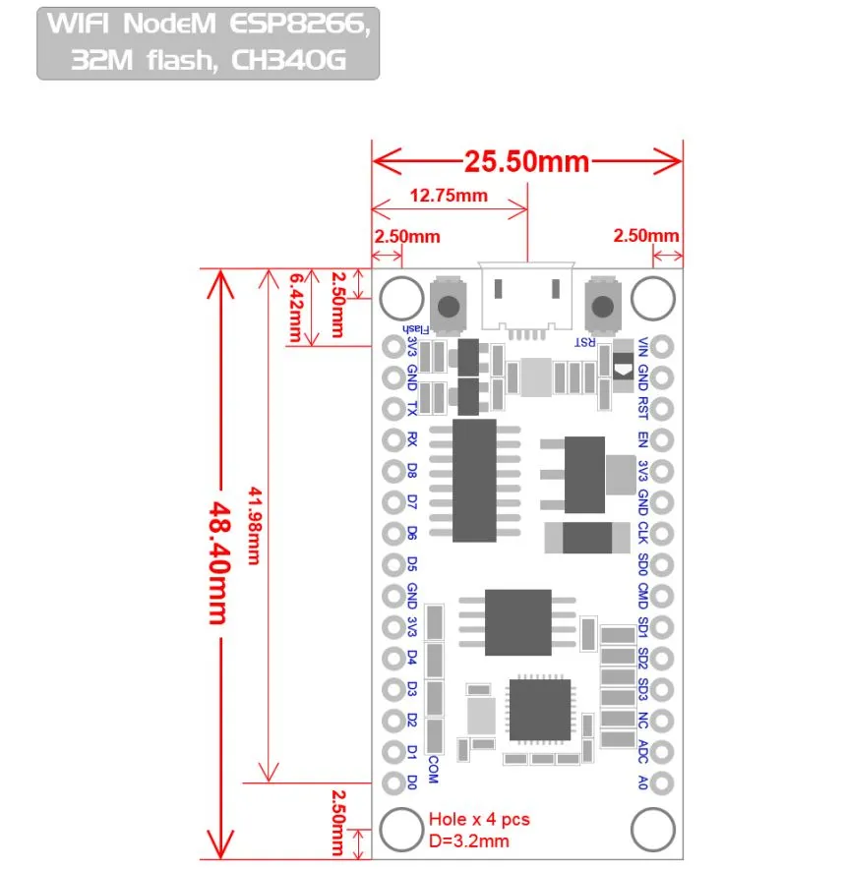

Figure 3.2 NodeMCU 2D View

**NodeMCU Specification:**

The NodeMCU development board is based on the ESP8266 microcontroller, and different versions of NodeMCU boards may have slight variations in specifications. As of my knowledge cutoff in January 2022, here are the general specifications for the NodeMCU ESP8266 development board:

**1. Microcontroller:** ESP8266 Wi-Fi microcontroller with 32-bit architecture.

**2. Processor:** Tensilica L106 32-bit microcontroller.

**3. Clock Frequency:** Typically operates at 80 MHz.

**4. Flash Memory:**

* Built-in Flash memory for program storage.
* Common configurations include 4MB or 16MB of Flash memory.

**5. RAM:** Typically equipped with 80 KB of RAM.

**6. Wireless Connectivity:**

* Integrated Wi-Fi (802.11 b/g/n) for wireless communication.
* Supports Station, SoftAP, and SoftAP + Station modes.

**7. GPIO Pins:** Multiple General Purpose Input/Output (GPIO) pins for interfacing with sensors, actuators, and other electronic components.

**8. Analog Pins:** Analog-to-digital converter (ADC) pins for reading analog sensor values.

**9. USB-to-Serial Converter:** Built-in USB-to-Serial converter for programming and debugging.

**10. Operating Voltage:** Typically operates at 3.3V (Note: It is crucial to connect external components accordingly to avoid damage).

**11. Programming Interface:** Programmable using the Arduino IDE, Lua scripting language, or other compatible frameworks.

**12. Voltage Regulator:** Onboard voltage regulator for stable operation.

**13. Reset Button:** Reset button for restarting the board.

**14. Dimensions:** Standard NodeMCU boards often have dimensions around 49mm x 24mm.

**15. Power Consumption:** Low power consumption, making it suitable for battery-operated applications.

**16. Community Support:** Active community support with extensive documentation and libraries.

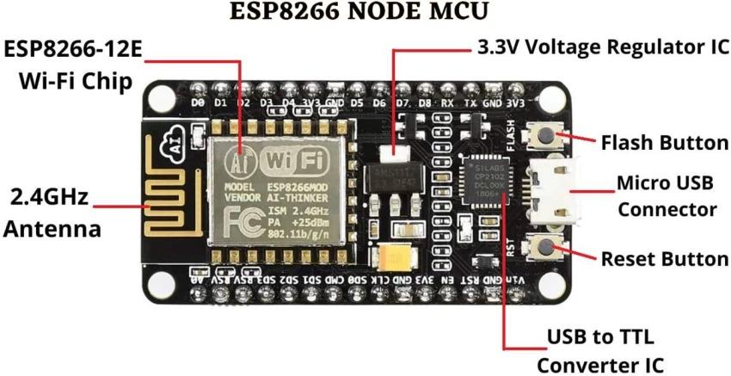

Figure 3.3: NodeMCU Parts

The NodeMCU ESP8266 development board typically has GPIO (General Purpose Input/Output) pins that can be used for various purposes, including interfacing with sensors, actuators, and other electronic components. Below is a common pinout configuration for the NodeMCU development board

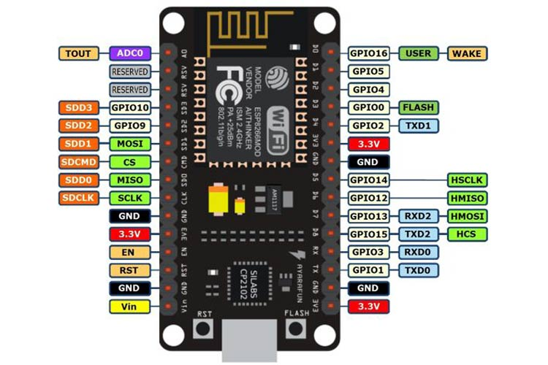

Figure 3.4: NodeMCU ESP8266 Pinout

ADC | A0 | GPIO16

EN | Enable | GPIO14

D0 | GPIO16 | GPIO12

D1 | GPIO5 | GPIO13

D2 | GPIO4 | GPIO15

D3 | GPIO0 | GPIO2

D4 | GPIO2 | GPIO9

D5 | GPIO14 | GPIO10

D6 | GPIO12 | GPIO3

D7 | GPIO13 | GPIO1

D8 | GPIO15 | TX (GPIO1)

D9 | GPIO3 (RX) | RX (GPIO3)

D10 | GPIO1 (TX) | D11 (MOSI)

D11 | MOSI | D12 (MISO)

D12 | MISO | D13 (SCK

**ADC**: Analog-to-Digital Converter pin for reading analog sensor values.

**EN** (Enable): Enable pin.

**D0-D8**: Digital GPIO pins.

**D9 (RX) and D10 (TX)**: Serial communication pins for programming and debugging.

**D11 (MOSI), D12 (MISO), D13 (SCK**): Pins used for SPI communication.

**D14 (SDA) and D15 (SCL)**: Pins used for I2C communication.

It's important to note that GPIO pins labeled as "D" (Digital) are typically used for general-purpose digital input/output. Additionally, GPIO pins labeled as "A" (Analog) can be used as analog inputs with the ADC. GPIO pins 6, 7, 8, 9, 10, and 11 have additional functions, so it's advised to refer to the specific NodeMCU documentation for detailed information on pin functionality and capabilities.

**3.2 Arduino software:**

Arduino microcontrollers are programmed using the Arduino IDE (Integrated Development Environment). Arduino programs, called “sketches”, are written in a programming language similar to C and C++. Every sketch must have a setup () function (executed just once) followed by a loop () function (potentially executed many times); add “comments” to code to make it easier to read. Many sensors and other hardware devices come with prewritten software line for sample code, libraries (of functions). Libraries are a collection of code that makes it easy for you to connect to a sensor, display, module, etc. For example, the built-in Liquid Crystal library makes it easy to talk to character LCD displays. There are hundreds of additional libraries available on the internet for download.

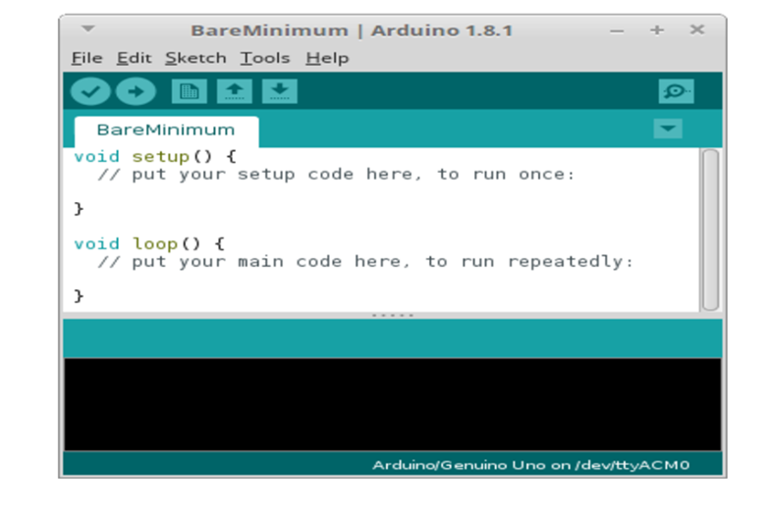

## Fig 3.5: Arduino IDE

## **3.3 Buzzer**

## It's a simple device that converts electrical signals into sound waves, producing a buzzing or beeping sound. Buzzers are widely used in various applications for providing audible notifications, alerts, alarms, and indications. Here's some information about buzzers.



Figure 3.6 Buzzer

**Working Principle:**

The working principle of a buzzer involves converting electrical energy into mechanical vibrations and then into sound waves. Here's a simplified explanation of how it works:

Mechanical Activation: In mechanical and magnetic buzzers, an electrical current causes a mechanical component (diaphragm or reed) to vibrate.

Sound Production: The vibrations of the mechanical component create pressure waves in the surrounding air, generating sound waves that we hear as a buzzing or beeping sound.

Piezoelectric Activation: In piezoelectric buzzers, an electrical signal is applied to a piezoelectric crystal. The crystal changes shape when subjected to the electric field, creating vibrations that produce sound waves.

Control and Sound Output: Buzzers can be controlled through voltage input, frequency modulation, or pulse width modulation (PWM). The pitch and volume of the sound generated can often be adjusted by varying the input parameters.

In summary, buzzers are versatile audio signaling devices used to provide audible alerts and notifications in various applications. They come in different types and configurations, allowing them to be tailored to specific needs and requirements

**Connection:**

Buzzers are rated to 5V, and the GPIO only delivers 3.3V.

**Specifications:**

Model Name/Number- AR083-5V-ACT-BUZZ

Size- 1 x 1 x 1 cm

Voltage- 5 V

Power Source- DC

## **3.4 MQ 5 gas sensor:**

The MQ-135 Gas sensor can detect gases like Ammonia (NH3), sulfur (S), Benzene (C6H6), CO2, and other harmful gases and smoke. Similar to other MQ series gas sensors, this sensor also has a digital and analog output pin. When the level of these gases go beyond a threshold limit in the air the digital pin goes high. This threshold value can be set by using the on-board potentiometer. The analog output pin, outputs an analog voltage which can be used to approximate the level of these gases in the atmosphere.

The MQ135 air quality sensor module operates at 5V and consumes around 150mA. It requires some preheating before it could actually give accurate results.

**Details of MQ5 Sensor**

The MQ135 is one of the popular gas sensors from the MQ series of sensors that are commonly used in air quality control equipment. It operates from 2.5V to 5.0V and can provide both digital and analog output. The pinouts and important components on an MQ135 Module is marked below

Note that all MQ sensors have to be powered up for a pre-heat duration for the sensor to warm up before it can start working. This preheat time is normally between 30 seconds to a couple of minutes. When you power up the module the power LED will turn on, leaving the module in this state till the pre-heat duration is completed.

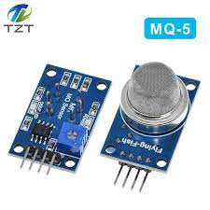

Figure 3.5: MQ5 Gas Sensor

**Technical Specifications of MQ5 Gas Sensor:**

Operating Voltage: 2.5V to 5.0V

Power consumption: 150mA

Detect/Measure: NH3, Nox, CO2, Alcohol, Benzene, Smoke

Typical operating Voltage: 5V

Digital Output: 0V to 5V (TTL Logic ) @ 5V Vcc

Analog Output: 0-5V @ 5V Vcc

**Detect Harmful Gasses using Digital Pin:**

The digital output pin of the sensor can be used to detect harmful gasses in the environment. The sensitivity of the digital pin can be controlled by using the 10k potentiometer. If the gas is detected the indicator LED D0 will turn on and the digital pin will go from logic high to logic low (0V). The LM393 Op-Amp Comparator IC is used to compare the actual gas value with the value set using the potentiometer. If the actual gas value increases than the set value then the digital output pin gets low.

Because of the onboard LM393 comparator IC the MQ135 Gas sensor module can also be used without the need of an external microcontroller. Simply power up the module and set the sensitivity of the digital pin using the potentiometer, then when the module detects the gas the digital pin will go low. This digital pin can directly be used to drive a buzzer or LED with the help of simple transistors.

**Measure PPM Value using Analog Pin:**

The Analog output pin of the sensor can be used to measure the PPM value of the required gas. To do this we need to use an external microcontroller like Arduino. The microcontroller will measure the value of analog voltage and perform some calculations to find the value of Rs/Ro where Rs is the sensor resistance when gas is present and Ro is sensor resistance at clean air. Once we find this ratio of Rs/Ro we can use it to calculate the PPM value of required gas using the graph below which is taken from the datasheet of MQ5 Sensor.

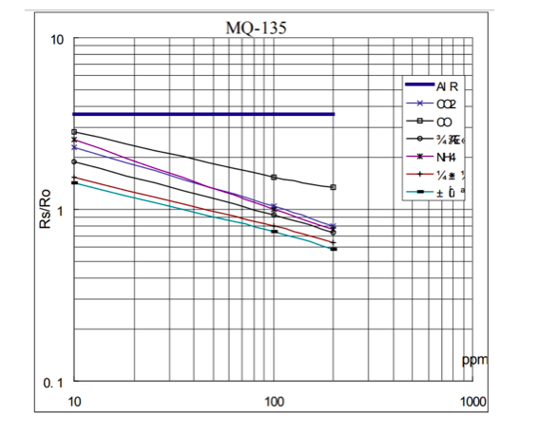

Figure 3.6: MQ5 Measurement of Smoke values

If you are just detecting the gas and not measuring the PPM then the module need not be calibrated or pre-heated and hence it is extremely simple to use. You can find these MQ Gas sensors commonly used in Gas/Smoke detectors and Air Quality Monitors.

# **CHAPTER 4**

# **Design and Coding**

## **4.1 Circuit Diagram**

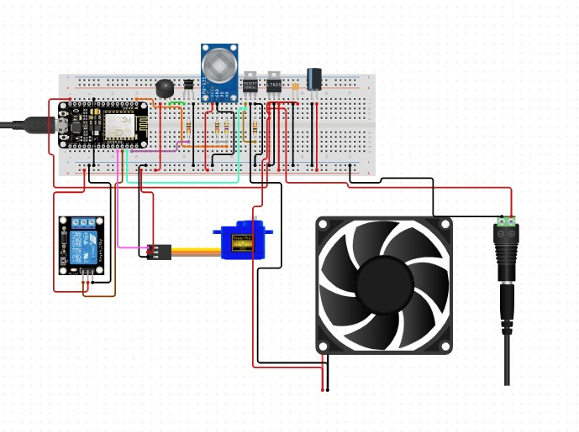

## **4.2 Code**

#include <ESP8266WiFi.h>

#include <Servo.h>

// Define pin connections

const int mqSensorPin = A0; // MQ sensor analog output connected to A0

const int servoPin = D4; // Servo motor control pin connected to D4 (GPIO 2)

const int buzzerPin = D5; // Buzzer control pin connected to D5 (GPIO 14)

const int relayPin = D6; // Relay control pin connected to D6 (GPIO 12)

// Threshold value for MQ sensor (adjust this based on your specific sensor and environment)

const int gasThreshold = 560;

// Create servo object

Servo servo;

void setup() {

// Start serial communication for debugging

Serial.begin(9600);

// Attach the servo to the defined pin

servo.attach(servoPin);

// Initialize servo to 0 degrees

servo.write(0);

// Set buzzer and relay pins as outputs

pinMode(buzzerPin, OUTPUT);

pinMode(relayPin, OUTPUT);

// Initialize buzzer and relay to OFF state

digitalWrite(buzzerPin, LOW);

digitalWrite(relayPin, LOW);

// Print initial status

Serial.println("System Initialized. Servo at 0 degrees, Buzzer and Fan OFF.");

}

void loop() {

// Read the analog value from the MQ sensor

int sensorValue = analogRead(mqSensorPin);

// Print the sensor value to the serial monitor (for debugging)

Serial.print("Gas Sensor Value: ");

Serial.println(sensorValue);

// Check if gas is detected (sensor value above threshold)

if (sensorValue > gasThreshold) {

// Move servo to 180 degrees

servo.write(180);

// Turn on the buzzer and relay (fan)

digitalWrite(buzzerPin, HIGH);

digitalWrite(relayPin, HIGH);

// Beep the buzzer once

digitalWrite(buzzerPin, HIGH);

delay(100);

digitalWrite(buzzerPin, LOW);

delay(100);

// Print status to serial monitor

Serial.println("Gas detected! Servo at 180 degrees, Buzzer and Fan ON.");

} else {

// Move servo back to 0 degrees

servo.write(0);

// Turn off the buzzer and relay (fan)

digitalWrite(buzzerPin, LOW);

digitalWrite(relayPin, LOW);

// Print status to serial monitor

Serial.println("No gas detected. Servo at 0 degrees, Buzzer and Fan OFF.");

}

// Short delay before the next sensor reading

delay(500); // Delay in milliseconds

}

# 

# **CHAPTER 5**

# **Results and Conclusion**

NodeMCU is an open-source IoT platform based on the ESP8266 Wi-Fi module, specifically designed to facilitate the integration of internet connectivity into various projects. It combines a powerful microcontroller with built-in Wi-Fi capability, making it an ideal choice for applications that require real-time data transmission, remote control, or monitoring. NodeMCU can be programmed using the Lua scripting language or the Arduino IDE, which significantly enhances its accessibility for both developers and hobbyists.

One of the standout features of NodeMCU is its affordability and energy efficiency, positioning it as a popular choice for a wide array of IoT projects, home automation systems, and smart devices. With a variety of General Purpose Input/Output (GPIO) pins, it supports a diverse range of sensors and modules, enabling users to build sophisticated systems, such as smart home devices, environmental monitoring setups, and safety systems like gas leakage detectors. Its versatility and ease of use have made it a staple in the maker community, empowering individuals to create innovative connected devices effortlessly.